**a)**

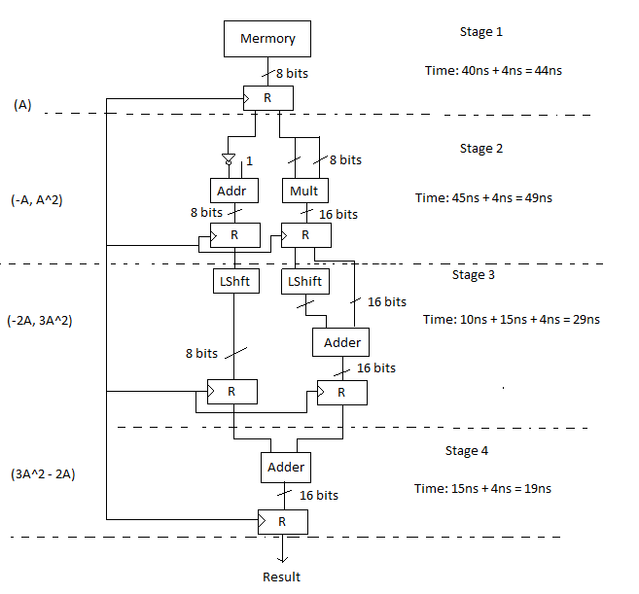

**b)**

The required time for the slowest stage is 49ns so, the clock cycle is 49ns.

***8 member array;***

Without pipeline required time is: 8 * (40ns + 45ns + 25ns + 15ns) = 125ns * 8 = 1000

With pipeline required time is: 49*4 + 49*7 = 539ns

Speedup = 1128 / 539 = 1.85

***Infinite number of elements;***

Speedup = tn / tp = 125 / 49 = 2.55

**c)**

The theoretical speed up is the number of stages. Smax = k = 4